Summary
The term refers to the December 16, 1944, German confrontation with the American forces in the Ardennes Mountains, a forested plateau range that extends from northern France into Belgium and Luxembourg. Even though Germany appeared to be beaten at this late point in the war, Hitler rallied his remaining forces and launched a surprise assault on the American soldiers in Belgium and Luxembourg. But Germany could not sustain the front, and within two weeks the Americans had halted the German advance near Belgium's Meuse River (south of Brussels). The offensive became known as the Battle of the Bulge because of the protruding shape of the battleground on a map.
The Ardennes were also the site of conflict earlier in World War II, in 1940, as well as in World War I, in 1914 and 1918.

Where did the bulge occur at the battle of the bulge?
The battle took place in Ardennes Mountains region in Belgium, elsewhere in Belgium, Luxembourg and Germany.
*The 'Bulge' was the general region of the Ardennes Forrest in Belgium, primarily around the town of Bastogne as in order to control the region and the local supply routes, one must have control of Bastogne (all 8 routes in the region came together in this town).

What was the significance of the battle of the battle of the bulge?
the significance was that Hitler was planning to take Antwerp spliting the allied forces and was the last offense the Germans made. It began on December 16, 1944 and lasted for one month. At first the Gemans were making good progress but at the town of Bastogne the 101st airborne held the town until Genreal Gerorge S. Patton saved the town with his 3rd Army. Overall the German offense ended on January 16th, 1945 with 84000 german causalties and 89,500 American casualties. So pretty much Hitler failed to capture antwerp and force the Allies to neoigate

In the battle of the bulge where did the battle take place?
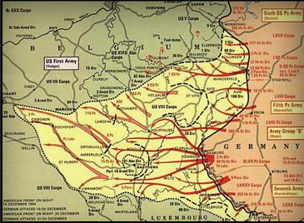
The primary location was the Forest of Ardennes. The battle took place in France and Belgium. The German objective was to establish a split in the Allied lines.

